Following rental prices are for the duration of the show, and include delivery and removal. SHOW COLORS: BLACK / SILVER
Wichita Area Builders Association’s 70th Annual Home Show!
March 7-10, 2024
Century II
Wichita, KS
Conventions

Trade Shows

Flags & Flag Poles

2900
S. Hydraulic

Wichita, Kansas 67216

316
-
943
-
1851

Fax 316
-
267
-
4804
Email:

info@henryhelgerson.com
RENTAL

ORDER

FORM

Company Name
Street Address

City

State

Ordered by:

Email:
Booth #

Phone

Z
i
p

C
o
d
e
P.O
.

#
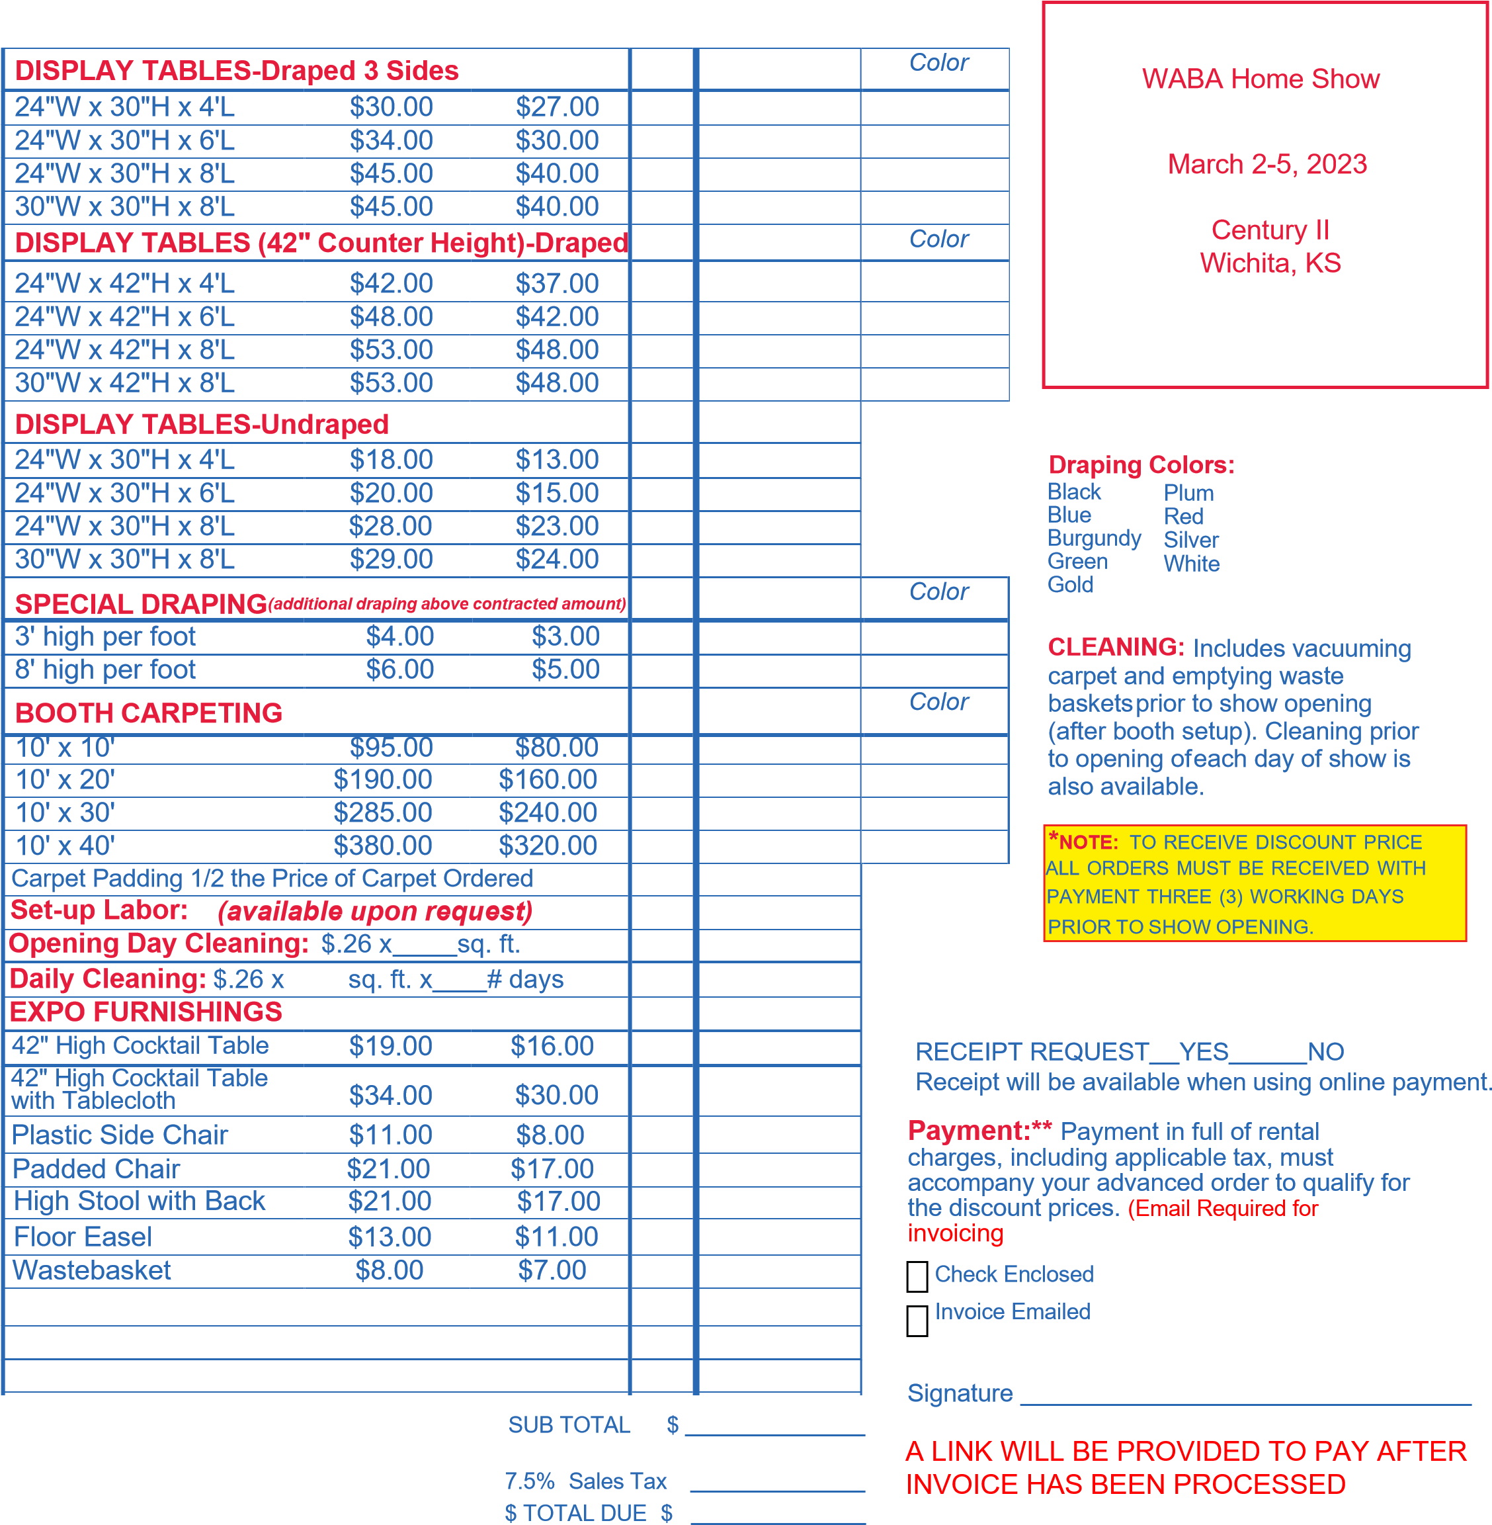
Standard Discount Total
Description Price Price* Qty. Price

